Version of Record: https://www.sciencedirect.com/science/article/pii/S0269749119322730
Manuscript_e897dc8bf0edfdfb56e8ca8e687365a9

- Development of a Calibration Chamber to Evaluate the Performance of Low-cost
- Particulate Matter Sensors
- T. Sayahiª, D. Kaufman^{b}, T. Becnel^{c}, K. Kaurª, A. Butterfieldª, S. Collingwood^{d}, Y. Zhang^{e},
- P.-E. Gaillardon^{c}, K.E. Kellyª
- ª University of Utah, Department of Chemical Engineering, 3290 MEB, 50 S. Central Campus Dr., Salt Lake City,
- UT, United States.
- ^{b} Kaufco Consulting, LLC. 409 East Corner Bridge Lane, Draper, UT, United States.
- ^{c} University of Utah, Department of Electrical and Computer Engineering, Laboratory for NanoIntegrated Systems,
- 50 S. Central Campus Dr., Salt Lake City, UT, United States.
- ^{d} University of Utah, Department of Pediatrics, 295 Chipeta Way, Salt Lake City, UT, Unites States.
- ^{e} University of Utah, Department of Internal Medicine, Division of Epidemiology, 295 Chipeta Way, Salt Lake City,
- UT, United States.
13

Abstract
- Low-cost particulate matter (PM) air quality sensors are becoming widely available and are
- being increasingly deployed in ambient and home/workplace environments due to their low cost,
- compactness, and ability to provide more highly resolved spatiotemporal PM concentrations.
- However, the PM data from these sensors are often of questionable quality, and the sensors need
- to be characterized individually for the environmental conditions under which they will be
- making measurements. In this study, we designed and assessed a cost-effective (~$700)
- calibration chamber capable of continuously providing a uniform PM concentration
- simultaneously to multiple low-cost PM sensors and robust calibration relationships that are
- independent of sensor position. The chamber was designed and evaluated with a Computational
- Fluid Dynamics (CFD) model and a rigorous experimental protocol. We then used this new
- chamber to calibrate 242 Plantower PMS 3003 sensors from two production lots (Batches I and
- II) with two aerosol types: ammonium nitrate (for Batches I and II) and alumina oxide (for Batch
- I). Our CFD models and experiments demonstrated that the chamber is capable of providing
- uniform PM concentration to 8 PM sensors at once within 6% error and with excellent reliability
- (intraclass correlation coefficient > 0.771). The study identified two malfunctioning sensors and
- showed that the remaining sensors had high linear correlations with a DustTrak monitor that was
- calibrated for each aerosol type (R²>0.978). Finally, the results revealed statistically significant
- differences between the responses of Batches I and II sensors to the same aerosol (P-
- value<0.001) and the Batch I sensors to the two different aerosol types (P-value<0.001). This
- chamber design and evaluation protocol can provide a useful tool for those interested in
- systematic laboratory characterization of low-cost PM sensors.
36

Capsule:

- Through simulations and rigorous experiments, this study designed and evaluated a cylindrical
- chamber capable of providing uniform concentrations and robust calibration relationships for
- laboratory calibration of low-cost air quality sensors.

41

42

1

© 2019 published by Elsevier. This manuscript is made available under the Elsevier user license https://www.elsevier.com/open-access/userlicense/1.0/

Keywords:

- Air quality, Calibration chamber, Low-cost sensors, Particulate matter, Evaluation of calibration
- chamber.

46

1. Introduction

- Human exposure to particulate matter (PM) is a major public health issue, contributing to lung
- cancer, cardiovascular diseases and premature mortality (Brook et al., 2010; Jensen, 2006;
- Raaschou-Nielsen et al., 2013). In 2016, ambient exposure to PM2.5 (PM with an aerodynamic
- diameter less than 2.5 μm) decreased average global life expectancy at birth by approximately
- one year with a greater reduction in life expectancy (approximately 1.2-1.9 years) in more
- polluted countries (Apte et al., 2018). PM2.5 concentration has conventionally been measured by
- expensive regulatory monitors. Although these regulatory monitors are highly accurate, their
- high costs and maintenance requirements limit the number of monitors that can be deployed.
- Consequently, these regulatory monitors are sparsely distributed and cannot capture intra-urban
- PM2.5 spatial variations resulting from local sources (Bell et al., 2010; Steinle et al., 2013).
- The emergence of low-cost light-scattering PM sensors (<$500) has provided an opportunity to
- understand neighborhood-scale differences in air pollution. A large number of such sensors have
- been deployed in various community air quality networks, such as PurpleAir (2019), AirBox
- (Chen et al., 2017) and CAIRSENSE (Jiao et al., 2016). However, data quality is a key concern
- for these PM sensors (Rai et al., 2017). They are not as accurate or precise as regulatory monitors
- (Shapiro et al., 2014). These sensors may be affected by environmental factors, such as humidity
- (Wang et al., 2015) and temperature (Gao et al., 2015). They may also experience drift over time
- (Clements et al., 2017; Sayahi et al., 2019). Many studies have relied on manufacturers’
- performance data rather than calibrating individual sensors under expected deployment
- conditions (Ali et al., 2015; Arvind et al., 2016; Du Plessis et al., 2016; Liu et al., 2015; Van den
- Bossche et al., 2015; Zhang et al., 2017). These studies assumed that their sensors’ default
- calibration factors are appropriate for the conditions of use and that their sensors do not exhibit
- intra-sensor variability. However, several studies have demonstrated significant intra-sensor
- variability both in the field and laboratory tests (Gao et al., 2015; Manikonda et al., 2016;
- Sayahi et al., 2019; Wang et al., 2015). Therefore, it is important to calibrate these inexpensive
- PM sensors before deployment because unreliable data may lead to unnecessary public alarm or
- complacency (Shapiro et al., 2014).
- The performance of low-cost PM sensors is commonly characterized using laboratory
- calibration. This type of calibration typically exposes the sensors and a research-grade/reference
- monitor to PM inside a cubic chamber. Laboratory calibration allows the sensors to experience a
- wide range of concentrations and environmental conditions in a matter of hours (Sousan et al.,
- 2016; Vercellino et al., 2018). Conversely, field calibration may require days or months, and
- even then, the sensors may not experience the target PM concentration range, PM source or

- environmental conditions. Moreover, it is logistically complicated to co-locate a large number of
- sensors with a reference monitor in the field for weeks or months.
- Calibration chambers have been a crucial tool in assessing laboratory low-cost air quality sensors
- because of their ability to provide controlled conditions (Papapostolou et al., 2017). Numerous
- studies have evaluated PM sensor performance in laboratory chambers (Table S-1). Initial
- studies took place in cubic chambers using decay tests; in these tests, an elevated particle
- concentration is reached, and then particle generation ceases. Subsequently, PM concentration
- decreases over time (Austin et al., 2015; Wang et al., 2015). Although these chambers are
- relatively inexpensive to build, they have difficulty generating stable PM concentrations, making
- it challenging to evaluate whether a low-cost PM sensor is capable of precise measurements
- because the PM concentration in the chamber is constantly dropping in a decay test. The time
- delay between the responses of PM sensors and the reference monitor is another potential source
- of error when using a decay test (Liu et al., 2017). To address the stability issue, Papapostolou et
- al. (2017) developed a sophisticated environmental chamber (cubic shaped) that can maintain a
- stable concentration over a wide range of concentrations (0-300 μg/m³ with less than 3.1%
- standard deviation).
- However, cubic chambers can have two disadvantages: particle loss at the edges and, more
- importantly, an uneven distribution of particles (or lack of understanding of this potentially
- uneven distribution). For example, Wang et al. (2015) and Hapidin et al. (2018) examined PM
- concentration uniformity by placing two low-cost sensors (same model) on different faces of
- their cubic chambers, and they suggested that PM concentration at these locations differed by
- less than 15% and 10%, respectively. However, their analysis relied on the assumption that their
- low-cost sensors’ responses exhibited no intra-sensor variability. Liu et al. (2017) developed a
- cylindrical chamber, in which the PM flows axially, and this type of chamber addresses the
- weaknesses of cubic chambers. They evaluated PM distribution in their chamber with seven
- tubes mounted at the bottom of the chamber where low-cost PM sensors are located. Sequential
- DustTrak measurements at those seven tube locations suggested that the spatial differences in
- concentration differed by less than 10%. However, this evaluation relied on the assumption that
- the PM concentration remained stable during the test. There is still a need for a cost-effective
- chamber that provides stable and uniform PM concentrations to the low-cost PM sensors as well
- as a strategy for evaluating spatial uniformity of particles within the chamber. Such a chamber
- will enable efficient evaluation and laboratory calibration of PM low-cost sensors.
- This study presents the development of a cylindrical calibration chamber that allows for the
- calibration of 8 low-cost sensors at once using continuous testing. The distribution of PM
- concentration was examined experimentally and computationally, resulting in a robust strategy
- for assessing the spatial distribution PM concentration within the chamber. Finally, 242
- Plantower PMS 3003 PM sensors from two different purchased batches were calibrated with this
- new chamber with a goal of identifying malfunctioning sensors and understanding intra-sensor
- variability.

2. Materials and methods

- This study developed and evaluated a cost-effective calibration chamber that can provide
- multiple low-cost PM sensors with a uniform PM concentration, regardless of their position in
- the chamber. The calibration system is shown in Fig. 1. This study focused primarily on the
- chamber design and used commercially available particles to evaluate the low-cost sensors.
- Several publications have discussed the aerosol generation and dilution strategies (Castell et al.,
- 2017; Li and Biswas, 2017; Liu et al., 2017; Papapostolou et al., 2017; Sousan et al., 2017). We
- used a Computational Fluid Dynamics (CFD) model to refine the chamber design before
- fabricating (described in Section 2.2). The CFD model and a rigorous experimental and
- statistical approach were applied to evaluate the spatial variability of PM concentrations within
- the chamber.
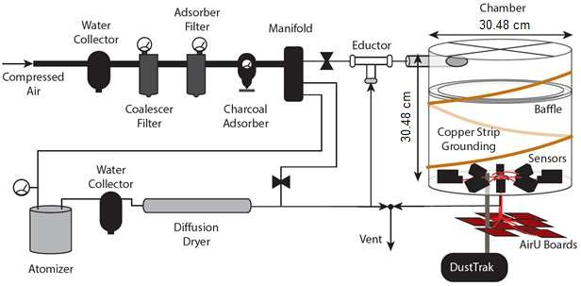
131

132
133 Fig. 1. Schematic of the calibration system. Note the dimensions are not to scale.
134

2.1. Chamber design
- The new chamber, with component costs of $692 (Table S-2), is capable of evaluating eight low-
- cost PM sensors at once and has an access port for a research-grade/reference monitor. It was
- designed with several key features to encourage uniform particle concentration at the inlets of the
- low-cost sensors (Fig. 1). These features included the cylindrical shape, the tangentially
- positioned inlet, the baffle, the outlet, and the anti-static design. The cylindrical shape limited the
- particle loss due to edge effects and provided a more uniform distribution of particles compared
- to conventional cubic chambers (Section 3.1). The inlet had turbulent flow (turbulence intensity
- of 4.51%-5.16% which falls in the medium to high turbulence case, (ANSYS, 2019) with
- incoming and exit flow velocities of 1-1.5 m/s. The outlet of the chamber was placed in the

- center of the chamber to allow the aerosols that migrate to the edges of the chamber to flow over
- the sensors while exiting. The chamber, which was made of acrylic, also had an anti-static
- system, consisting of a helical pattern of grounded copper strips and wire (Fig. 1). An ohmmeter
- was used to verify all connections were sufficiently grounded. Generated aerosols can have high
- electrostatic charges, and the anti-static system limited particle deposits on the walls, therby
- reducing the need for cleaning (Tian et al., 2017).
151

2.2. Computational fluid dynamics evaluation
- CFD simulations using ANSYS FLUENT software predicted the spatial distribution of aerosols
- within the cylindrical chamber and permitted the iterative refinement of the chamber design.
- Using the same conditions and chamber volume, this study also compared CFD simulations of
- aerosol concentrations for a cubic chamber. The CFD simulations employed a realizable K-ε
- turbulence model and Eulerian-based mixture model that treats each interpenetrating phase as a
- continuous fluid, where the individual particles are not tracked. This model provides accurate
- results when the concentration of one of the phases is low and can be assumed to be well mixed.
- The primary benefit of using this model was that it had a much lower computational overhead
- than traditional Eulerian-Lagrangian coupled simulations, where each particle must be
- individually tracked and all collisions are resolved (Tu et al., 2013). Table S-3 summarizes the
- simulation settings for the newly developed cylindrical chamber and a cubic chamber with the
- same volume.
165

2.3. Experimental evaluation
- The experiments included three types of tests (stability, repeatability, and rotation, described in
- Section 2.3.3) to assess the spatial distribution of PM within the chamber. After the chamber
- evaluation, this new chamber was used to evaluate the performance of 242 low-cost sensors
- compared to a research-grade instrument (TSI DustTrak 8530) and to identify malfunctioning
- sensors as well as to understand inter-sensor variability before deploying them in the field.
172

2.3.1. Experimental system

- The laboratory calibration system consisted of a particle generator, a diffusion drier (if needed), a
- dilution system, and the newly designed cylindrical calibration chamber with 8-low cost PM
- sensors and a research-grade monitor (Fig. 1).
177
- Aerosol generation. Two different types of particles, alumina oxide and ammonium nitrate,
- were utilized for calibrating the low-cost sensors. Alumina oxide represented a dry and non-
- cohesive dust, and this was generated by a Palas solid particle dispenser (RBG 1000-C). The
- alumina oxide particles have a density of 4000 kg/m³ (Duralum, Washington Mills, Niagara
- Falls, NY, USA) and a mean mobility diameter of 470 nm (Fig. S-1-A). Ammonium nitrate is a
- key component of PM2.5 concentration in Salt Lake City where the sensors are being deployed.

- During winter in Salt Lake City, ammonium nitrate contributes more than 50% of PM2.5 mass
- (Baasandorj et al., 2018; Kelly et al., 2013; Sayahi et al., 2019). The 95% pure ammonium
- nitrate has a density of 1700 kg/m³ (Alfa Aesar, ThermoFisher SCIENTIFIC, ACS) and a mean
- mobility diameter of 137 nm (Fig. S-1-B). The ammonium nitrate particles were generated with a
- single-jet atomizer (TSI model 9302) and clean dry air. A building compressor provided the
- clean, dry air, which was further cleaned using an Enmet air filtration panel (5 μm, Ann Arbor,
- Michigan) that included a water collector bowl, a coalescer filter, a charcoal absorber, and an
- adsorber filter. Before introducing the aerosol flow to the calibration chamber, a diffusion dryer
- (TSI 3062) filled with dry silica gel reduced the humidity of the aerosol stream. The range of
- relative humidity inside the chamber during the calibration tests was 7.3% to 9.9%, measured
- with an Omegaette temperature/humidity meter (Omega Engineering, model HH314). The
- temperature of the chamber was similar to that of the laboratory, which ranged from 21.7 °C to
- 25.1 °C (measured with HH314). Some studies have reported that low-cost PM sensors may be
- affected by environemtal factors such as humidity (Wang et al., 2015) and temperature (Gao et
- al., 2015), but several other studies found negligible correlation between the sensors’ responses
- and those factors (Han et al., 2017; Holstius et al., 2014; Kelly et al., 2017; Sayahi et al., 2019).
- The small differences in relative humidity and temperature during the calibration tests were
- unlikely to have affected the results although as discussed in Section 3.6 the addition of
- temperature and humidity control would be beneficial for systemically evaluating these
- environmental factors.
204
- Research-grade monitor. A TSI DustTrak 8530 (Rivas et al., 2017) was placed directly below
- the calibration chamber, and a representative sample from the chamber flowed directly into the
- DustTrak (3 L/min) via conductive tubing positioned at the height of the low-cost sensors’ inlets.
- The DustTrak was equipped with a PM2.5 inlet, and its mass concentration estimate was
- corrected for each type of aerosol with a calibration factor, developed from co-located
- measurements with an AirMetrics MiniVol, which is a filter-based monitor. The MiniVol was
- operated with a PM2.5 inlet and a flow rate of 5 L/min. The MiniVol’s filter was pre- and post-
- weighed, in triplicate, to obtain an average mass concentration, which is used to develop a
- correction factor for each aerosol type. The raw DustTrak readings were divided by an
- appropriate correction factor for each aerosol type (1.78 or 0.959 for ammonium nitrate and
- alumina oxide, respectively).
216
- Low-Cost Sensors. The Plantower PM sensors (PMS 3003) were evaluated in this study (Fig. S-
- 2). In this light-scattering based sensor, a fan with a rate of 0.1 L/min routes air past a tightly
- focused laser beam. Each particle passes through two 90-degree turns before passing the laser.
- The laser wavelength is 640 ±10 nm, measured with a Lambda 35 spectrophotometer
- (PerkinElmer, Inc). The manufacturer reported that the sensor’s response time is less than 10
- seconds and its mean time to failure is more than three years. They also reported that the sensor’s
- effective PM2.5 concentration range is 0~500 μg/m³ and that the sensors have an accuracy of ±10

- μg/m³ (for concentrations between 0~100 μg/m³) and ±10% (for concentrations between 100-500
- μg/m³).
- The PMS sensor was integrated into an in-house sensing system called AirU. In addition to the
- PMS 3003 sensor, AirU comprises a custom-printed circuit board, a Texas Instruments
- HDC1080 temperature and humidity sensor, and a MiCS-4514 reduction/oxidation gas sensor.
- The PMS3003 sensors were connected directly to the AirU circuit board, which in turn was
- powered through an FCC-certified 120V AC input, 5V DC output power adapter with a 1 amp
- current rating. The PMS3003 draws 60mA, and the total current draw of the AirU (including the
- PMS3003) is 120mA. The PMS3003 sensor directly received this 5V source with minimal
- additional filtering supplied by decoupling capacitors, which were also mounted on the AirU
- circuit board. PM measurements were sent once a second from the PMS3003 to the AirU. These
- measurements were accumulated, and every 15 seconds the sum of the measurements was
- divided by the number of measurements for the time period. The result was sent to a private
- database over WiFi. No data filtering was applied prior to the data collection/storage. The PMS
- sensors were placed in a 56.1 mm diameter, circular sensor holder within the chamber. Each
- sensor was placed at 45-degree intervals along the circular holder (Fig. S-3), and the AirU boards
- were located outside the chamber (Fig. 1).
241

2.3.2. Calibration test protocol

- For each sensor calibration test, the calibration chamber was allowed to reach a steady-state
- target concentration based on DustTrak readings, and measurements at each concentration were
- collected for 10 min. The calibration test for all 242 low-cost sensors included 5 targets ranging
- from a PM2.5 concentration <5 μg/m³ (except the stability test, Section 2.3.3) to approximately
- 150 μg/m³ (except Section 3.5). Finally, the performance of eight sensors was also evaluated at
- 10 steady-state concentrations ranging from <5 μg/m³ to 1000 μg/m³ in a continuous test.
- Both the DustTrak and the PMS sensors collected data at 15-seconds intervals. The data were
- first time-matched and then averaged over one minute. A linear model was individually fit to the
- minute-by-minute data of DustTrak and each sensor.
252

2.3.3. Robustness of experimental calibration

- The following three tests provided an estimate of particle distribution inside the newly designed
- calibration chamber.
- Stability test. The stability test was performed once at 5 steady-state target concentrations (10
- min at each concentration), using DustTrak measurements (Table 1). The stability of the
- chamber at each concentration step was assessed using the standard deviation (SD) of the
- DustTrak measurements and the relative percentage of standard deviation (%RSD):

260
261

where R ef
%RSD =(SD(Ref ss ))×100
Ref ss

ss is the average of the DustTrak readings at each steady-state concentration.
(1)

- Repeatability test. To evaluate the ability of the chamber to generate reproducible linear
- calibration curves for each of the sensors, the 5-point calibration (described in Section 2.3.2) was
- repeated three times for eight low-cost sensors. We used the intraclass correlation coefficient
- (ICC), a widely used reliability index in test-retest analyses, to examine the repeatability
- (Cicchetti, 1994). More specifically, for each low-cost sensor, we calculated the proportion of
- residual variance after calibration, which was not caused by the repeated experiments. The
- calculated ICC ranges from 0 to 1. A high ICC index indicates a lower impact of repeated
- experiments on the calibration test and hence better repeatability in the calibration model. We
- used the cluster bootstrap approach to calculate the 95% confidence interval of ICC for each
- sensor. We then followed the guideline developed by Cicchetti (1994), and interpreted the ICC
- values less than 0.4, between 0.4 and 0.59, between 0.60 and 0.74, and greater than 0.75 as poor,
- fair, good and excellent, respectively.
- Rotation test. The rotation test complemented the repeatability test and examined the robustness
- of the calibration lines for each sensor at different positions in the chamber. In the rotation test,
- eight sensors were evaluated once at four different positions. In other words, the test was
- repeated four times, and in each test, the sensors were rotated 90-degrees in relation to the center
- of the chamber (Fig. S-3). In this test, instead of reporting the concentration differences of
- different sensors (of the same model) at various positions as an indication of the particle
- distribution (Hapidin et al., 2018; Wang et al., 2015), each sensor was compared to its own
- calibration data in the different positions. This method eliminated the errors associated with
- intra-sensor variability. We used the same ICC approach in the reliability test, discussed above,
- to examine the impact of sensor location/rotation.
284

2.3.4. Calibrating Plantower PMS 3003 sensors

- This study calibrated 242 Plantower PMS 3003 sensors from two different production lots
- (Batches I and II). The sensors had consecutive numbers (PMS 1- PMS 242). Batches I and II
- included 154 (PMS 1-PMS 154) and 88 sensors (PMS 155-PMS 242), respectively. They were
- purchased from Beijing Plantower Co., Ltd, in June 2017 and August 2018, respectively. Batch
- I was evaluated using both ammonium nitrate and alumina oxide aerosols; however, Batch II
- was evaluated only using ammonium nitrate particles. This calibration provided the slope,
- coefficient of determination (R²), intercept, and bias for all 242 sensors. Moreover, this study
- assessed four low-cost sensors from each batch to investigate the precision at five steady-state
- concentrations. In addition, the pairwise Spearman’s correlation coefficient (SCC) was used to
- evaluate the strength and direction of the correlation between each pair of PMS sensors for each
- test of eight sensors for both Batch I and II. The SCC ranges from -1 to 1, where the closer the

- SCC is to ±1, the stonger the association. SCC values greater than 0.80 indicate a very strong
- association (Daniel, 1990).
- It should be noted that the performance criteria for low-cost sensors do not yet exist, but other
- studies have used these same metrics (slope, intercept, R², bias) for their evaluations of low-cost
- PM sensors (Sousan et al., 2016, 2017). In addition, the Environmental Protection Agency
- (EPA, 2006, 2018) also uses these metrics as well as the coefficient of variation (CV) in their
- criteria for continuous PM2.5 monitors and candidate equivalent methods, and we discuss these
- criteria for comparison purposes.
- The PMS sensor bias was calculated as the mean of the ratio of each PMS sensor measurement
- at time t (PMSt) to the corresponding reference reading at time t (Reft):

307
Bias = mean (^{PMS}t −1)×100
t
Ref
Reft measurements less than 1 μg/m³ were excluded from calculating sensor bias.
(2)

- The precision of the four low-cost sensors from each batch (a total of eight sensors) was assessed
- at four steady-state concentrations (PMSss) in comparison to a reference monitor using the CV:

310
311
312
313
CV =(SD(PMSss ))×100
Ref ss

where Ref ss is the average of reference monitor at each steady-state concentration.

Result and discussion
  - CFD simulation
(3)

- This analysis investigated the ammonium nitrate particle concentration distribution in the
- cylindrical chamber at a flow rate of 15 L/min. The boundary conditions and the settings for the
- CFD model can be found in Table S-3. This model was tested for particle sizes up to 10 µm with
- no appreciable change in results. This CFD analysis is valid for Knudsen numbers significantly
- less than one. Fig. S-4 shows the fraction of the volume occupied by the particles in the overall
- control volume (the chamber) as time progresses. It takes the chamber about 10 minutes to reach
- steady-state. Fig. 2 represents the volume fraction profiles of the particles at the center of the
- sensors’ inlets within a ± 10 mm radial margin from the centerline (called inlet location, Fig. S-
- 5). The two smaller concentric circles in the figure represent the inlet of the DustTrack. The
- maximum concentration difference among all the sensor positions at the inlet location is 5.50%
- (Table S-4). This indicates that the cylindrical chamber is capable of providing a uniform
- concentration at the inlet location within 6% error. The difference in concentration on one side of
- the chamber is due to the inlet position and angle of the inlet. The volume fraction is lowest at
- the point where the DustTrak inlet is located. One potential reason is that the DustTrack inlet
- pulls a negative pressure while the rest of the chamber is at atmospheric pressure.
- This analysis also provided a comparison between a cubic chamber and a cylindrical one at the
- same conditions. The CFD simulation settings and boundary conditions for the cubic chamber

- are summarized in Table S-3. Fig. S-6 shows the volume fraction profiles at the six walls of the
- cubic chamber on which the sensors were assumed to be located. Comparing the concentrations
- at the center of each face of a cubic chamber showed that the smallest difference was 7.48% and
- the largest difference was 16.4% (Table S-4). Concentration differences could be even larger
- than 16.4% if one compared a center point on one face with a different location on another face
- (not the center). The results indicate that this cylindrical chamber can provide a more uniform
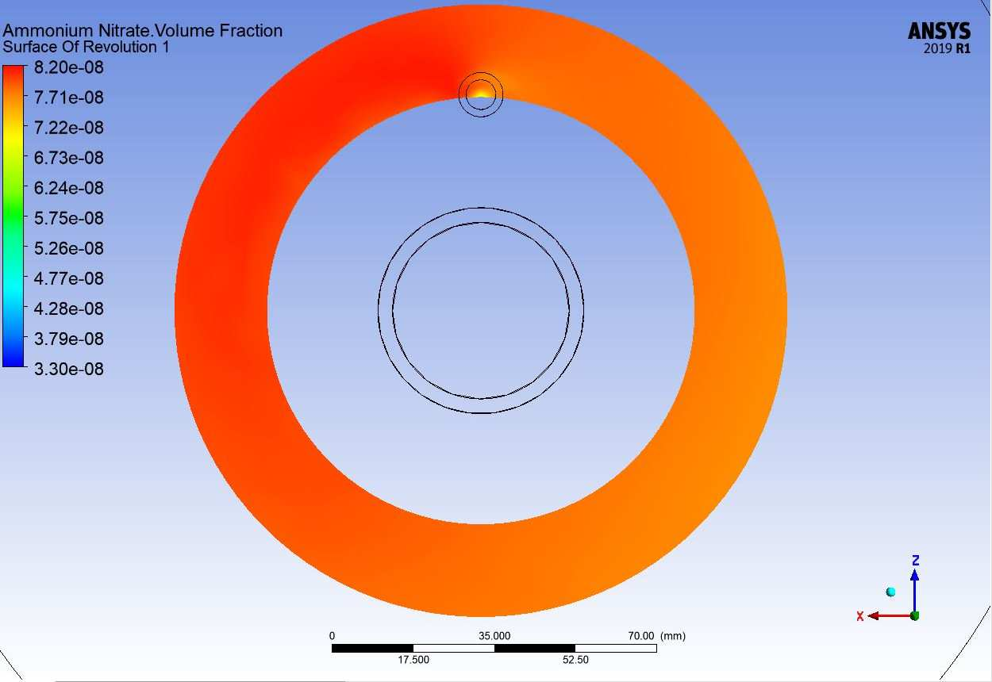
- distribution of particles than a cubic chamber.

338
- Fig. 2. Volume fraction distribution at the inlet location, a ±10 mm radial margin from the
- centerline of the sensors’ inlets. The two smaller concentric circles in the figure represent the
- inlet of the DustTrack. The larger concentric circle indicates the chamber outlet.

3.2. Effect of sensor location on calibration

- Stability, repeatability and rotation experiments were performed to evaluate the robustness of the
- sensor calibrations to position inside the newly designed chamber.

3.2.1. Stability test

- Table 1, Figs. 3 and S-7 show the results of the chamber stability test for five different
- concentrations of ammonium nitrate and alumina oxide. The shaded area in the figure shows the
- transition between the steady-state concentrations. The SD and %RSD ranges for all target
- concentrations during the stability test of the new chamber were low (Table 1) and in the same
- range as those reported by Papapostolou et al. (2017) (SD=0.2-4.3, %RSD=1.4-3.1%). These
- low SD and %RSD indicate that the chamber system has very good stability over the tested range
- of concentrations. As shown in Table 1, higher PM2.5 concentrations showed larger standard
- deviations and relative standard deviations. The same observation was reported by Papapostolou

- et al. (2017). It should be noted that %RSD is independent of concentration, making %RSD
- easier to compare with other studies (Eq. 1, Table 1).
- Papapostolou et al. (2017) discussed that the stability of PM concentrations in a chamber is
- mainly due to two factors: a) the ability of the particle generator to provide aerosol
- concentrations, and b) the uniform distribution of particles inside the chamber. In this study,
- another source of error in creating a consistent aerosol concentration could be the fluctuations in
- the clean air flow, which was provided by the building’s compressor. Our results indicated that
- the Palas RGB-C’s aerosol generation was less stable than the TSI single-jet atomizer, as
- evidenced by the larger variations in the alumina oxide tests. In order to reduce other sources of
- error and focus on the ability of the chamber to provide uniform PM concentrations, the
- repeatability and the rotation tests (Section 3.2.3) were only conducted with ammonium nitrate
- particles.
366
- Table 1. Stability test results for ammonium nitrate and alumina oxide aerosols using SD and
- %RSD (Eq. 1) parameters for five target concentrations.

 | Ammonium nitrate  Target concentration μg/m³ SD μg/m³ |  | %RSD | Alumina oxide  Target concentration μg/m³ SD μg/m³ |  | %RSD
State 1 | 8.69 | 0.506 | 5.82 | 12.5 | 0.654 | 5.57
State 2 | 39.4 | 1.95 | 2.43 | 57.0 | 3.58 | 6.29
State 3 | 80.2 | 2.15 | 5.45 | 96.2 | 7.73 | 8.03
State 4 | 101 | 3.63 | 2.33 | 140 | 8.74 | 6.26
State 5 | 156 | 4.08 | 4.06 | 175 | 9.04 | 5.17
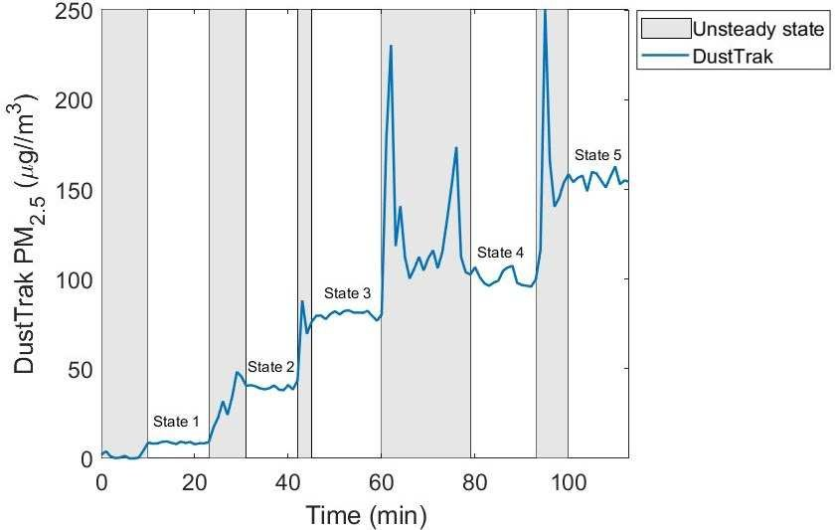
- States 1-5 are the 5 steady-state concentrations for each stability test.

370
- Fig. 3. Concentration time-series for the ammonium nitrate stability tests.

3.2.2. Repeatability and rotation tests

- Table 2 summarizes the ICC index values calculated for eight sensors (i.e., PMS1-PMS8, Fig. S-
- 2) compared to the DustTrak. The ICC values for repeatability and rotation tests ranged from
- 0.961 to 0.999 and from 0.771 to 0.851, respectively, which indicate excellent reliability of the
- calibration tests regardless of the repeat number or the position of the sensors inside the chamber.
- For each sensor, the ICC value for the repeatability test was consistently higher than that for the
- rotation test. The estimated uncertainty (i.e., the 95% CI) for repeatability was also consistently
- smaller than that for the rotation test. Although the impact of rotating the sensors inside the
- chamber on the linear calibration model was greater than the impact of repeating the experiment,
- the ICC index values (>0.75) of the sensors show that the calibration model results are robust to
- both the repeatability and rotation tests.
- The ICC approach was also used to describe the repeatability of each sensor’s response
- compared to itself in three repeated tests (within-sensor variability) and the repeatability of one
- sensor compared to the other seven sensors during the same test (between-sensor variability,
- three tests). The results showed that the ICC for within-sensor variability reliability ranged from
- 0.955 to 0.980, and the ICC for between-sensor variability ranged from 0.969 to 0.991. These
- ranges of ICCs are indicative of excellent reliability (Cicchetti, 1994).
389
390 Table 2. Results of repeatability and rotation tests.

Repeatability Rotation
391

ICC 95% CI ICC 95% CI

PMS1 0.987 |  | (0.938, 1.000) | 0.771 | (0.528,0.964)
PMS2 0.965 |  | (0.916, 0.999) | 0.851 | (0.647,0.997)
PMS3 0.999 |  | (0.981, 1.000) | 0.823 | (0.555, 1.000)
PMS4 0.999 |  | (0.978, 1.000) | 0.809 | (0.655, 0.968)
PMS5 0.999 |  | (0.967, 1.000) | 0.838 | (0.649, 1.000)
PMS6 0.961 |  | (0.841, 1.000) | 0.833 | (0.666, 0.998)
PMS7 0.985 |  | (0.928, 1.000) | 0.790 | (0.597, 1.000)
 | PMS8 0.995 (0.978, 1.000) 0.843 (0.595, 0.977)
392
393 | 3.3. Effect of aerosol type
394 | The evaluation of the PMS 3003 performance for two different particle types (alumina oxide and
- ammonium nitrate) began with a PM2.5 time-series evaluation of the DustTrak and four PMS
- sensors at five steady-state concentrations (Fig. S-8). The figure illustrates that the PMS sensors
- track the DustTrak PM2.5 concentrations. As shown in Fig. S-8-A, the PMS sensors from Batch I
- overestimated ammonium nitrate PM2.5 concentrations compared to the DustTrak but
- underestimated alumina oxide concentrations compared to DustTrak (Fig. S-8-B). Kelly et al.
- (2017) also reported that the PMS 3003 underestimated alumina oxide PM2.5 concentrations in a

- wind-tunnel test. Many studies suggested that the differences in the response of light-scattering
- based sensors to different aerosol types can be attributed to variations in aerosol optical
- properties (Kelly et al., 2017; Liu et al., 2017; Sousan et al., 2016; Wang et al., 2015).
- A linear model was fit to each of the 242 sensors based on the 5-point calibration curve. Fig. 4
- shows the distribution of the slopes, intercepts, and goodness of fit metrics (R²) of these fits as
- well as bias measurements. For both aerosol types, the PM2.5 readings of Batch I PMS sensors
- were highly correlated with the reference instrument, R² of 0.995-0.999 for ammonium nitrate
- and R² of 0.978-0.998 for alumina oxide. Clements et al. (2017) suggested that low-cost sensors
- can complement existing monitoring networks and enhance the spatial coverage of PM data if
- they have R²>0.4 with a federal reference/equivalent method. As discussed in Section 2.3.4,
- performance standards for low-cost sensors do not yet exist; for comparison purposes, we
- discussed EPA criteria for continuous PM2.5 monitors and candidate equivalent methods. The
- correlations between the PMS sensors and the DustTrak meet the EPA’s criteria for continuous
- PM2.5 monitors (r>0.9 or R²>0.81; EPA, 2018) and for candidate equivalent methods (r>0.97 or
- R²>0.94; EPA, 2006). However, the slopes of the linear model were not generally within the
- EPA’s criteria for continuous PM2.5 monitors (1 ± 0.1; EPA, 2018) and varied significantly for
- the two different types of aerosols (Student t-test, p-value<0.001) from 0.414-0.645
- (underestimation for alumina oxide) to 0.988-1.36 (overestimation for ammonium nitrate). The
- average of intercepts of all Batch I sensors were -1.37 μg/m³ (range of -3.88-2.47 μg/m³) and -
- 1.94 μg/m³ (range of -5.84-5.05 μg/m³) for ammonium nitrate and alumina oxide, respectively.
- The small intercepts for the Batch I sensors for both aerosol types were generally within the EPA
- (2006) acceptable range for candidate equivalent methods (± 5 μg/m³).
- The average bias values for all the Batch I sensors for ammonium nitrate and alumina oxide were
- 9.53% and -49.6%, respectively. The small positive bias for Batch I sensors with ammonium
- nitrate shows that the difference between the sensor and the reference instrument is small and
- within the EPA (2018) criteria for continuous PM2.5 monitors (± 10%). However, the large
- negative bias for alumina oxide exceeds EPA (2018) criteria. It is also an indication of the
- underestimation of PM2.5 concentrations. Sousan et al. (2017) also reported different bias values
- for the same sensor (Footbot) in response to different aerosol types (-12% for Arizona air dust
- and < -46% for salt and welding fume).

431
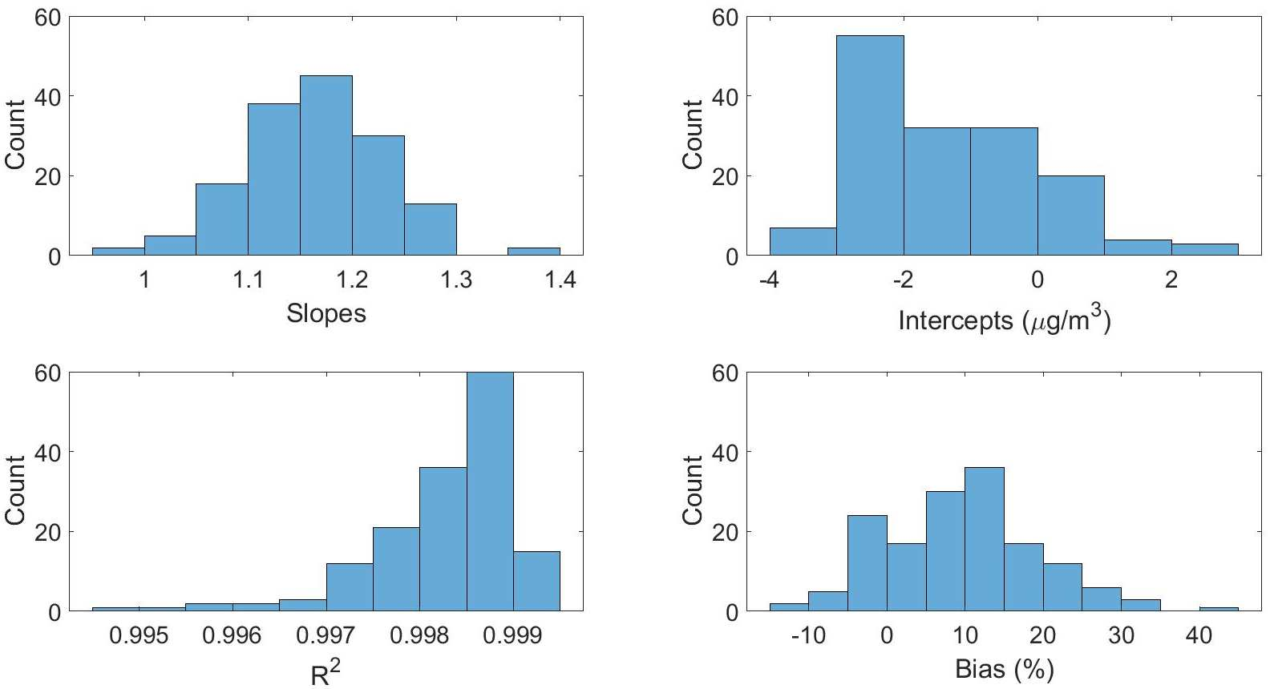
(A)
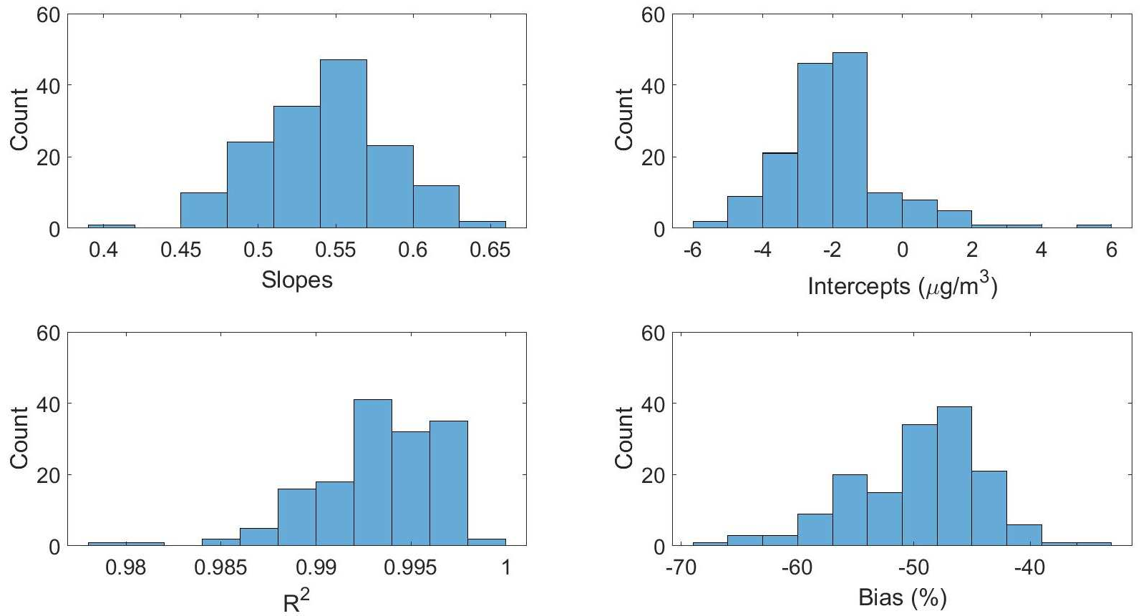
(B)
- Fig. 4. Frequency distribution of slopes, intercepts, coefficients of determination, and bias for
- 154 Batch I sensors for calibration with ammonium nitrate (A) and alumina oxide (B) aerosols.
- Note that the scales in the x-axes are different.
- The precisions of the four representative PMS sensors were between 1.96% and 10.2% (average
- of 5.06%) for ammonium nitrate and between 1.17% to 5.91% (average of 3.65%) for alumina
- oxide. The low precision values reflect the ability of the sensors in replicating the concentration
- measurements (NIOSH, 2012). These CVs are within EPA’s acceptable measurement
- uncertainty for continuous PM2.5 monitors (CV < 10%, Table S-5; EPA, 2018).

3.4. Comparison of Batches I and II sensors

- Comparing the response of Batches I and II sensors revealed that Batch I slightly overestimated
- ammonium nitrate PM2.5 concentrations (mean slope = 1.16 and bias = 9.53 %), but Batch II
- slightly underestimated ammonium nitrate PM2.5 concentrations (mean slope = 0.919 and bias = -
- 4.52 %, Fig. S-9). As with Batch I, the Batch II sensor responses were highly correlated with the
- DustTrak (R² of 0.968-0.999). These slopes and correlations meet EPA (2018) criteria for
- continuous PM2.5 monitors. All of these results in the following sections excluded the two
- malfunctioning sensors, which are further discussed below. As shown in Fig. S-10, the slopes of
- Batch I sensors differed significantly from those of Batch I (Student t-test, p-value<0.001). This
- result indicates that sensors purchased at different times could have different responses.
- However, the pairwise SCCs showed very strong positive correlation for each pair of eight
- sensors in the same test (>0.972 for Batch I and >0.978 for Batch II). Table S-6 shows the
- pairwise SCCs for one representative test from each batch.
- Eight sensors from Batch II have much lower slopes than the mean slopes (0.5 to 0.7) and biases
- (-50 % to -20 %) although they still have high R² values (0.995-0.997). This means that these
- sensors underestimate the PM2.5 levels more than the other sensors. However, they could still be
- deployed in the sensor network using proper correction factors. These results provide indications
- of intra-sensor variability and the importance of calibration before field deployment of the
- sensors. Possible explanations for the different responses of the batches include manufacturer
- modification of their software that converts the signal to PM concentration or manufacturing
- differences in the photodetector.
- One of the goals of laboratory evaluation was to identify defective sensors and avoid deploying
- them in the field. The malfunctioning sensors were identified by a poor coefficient of
- determination (R² < 0.3, Moore et al., 2013). Two out of 242 evaluated sensors were classified as
- malfunctioning (PMS 163 and PMS 242). Neither sensor tracked the PM2.5 concentration
- measurements of DustTrak. Sensor PMS 163 readings ranged from 0-24.3 μg/m³ with R² of
- 0.018 (Fig. S-11) while sensor PMS 242 constantly read zero with R² of NaN (not a number),
- even though both sensors were exposed to PM2.5 concentrations up to 150 μg/m³. Both sensors
- were dismantled to find possible reasons for their behavior. Nothing suspicious was found in
- sensor PMS 163; its low readings could be due to laser misalignment or a manufacturing defect
- in the sensor’s laser, photodetector or electronics. Sensor PMS 242’s laser chamber was filled
- with small pieces of white paper (Fig. S-12) preventing the laser light from reaching the particles
- or the photodetector.
473

3.5. Sensor behavior at higher concentrations

- Exposing eight PMS sensors to ammonium nitrate PM2.5 concentrations up to 1000 μg/m³
- showed that the sensors maintained a linear response up to a concentration of 150 μg/m³ (R² of
- 0.995-0.999, Fig. S-13). However, the linearity deteriorated at higher concentrations. The exact
- physical reason behind the non-linear relationship of PMS 3003 sensors and the reference

- instrument is unclear. A second-order polynomial fit all the data (R² of 0.998-0.999, range: 5 -
- 1000 μg/m³) better than a linear model (Fig S-14). This non-linear behavior of low-cost PM
- sensors above a certain concentration was also seen in other laboratory studies (Austin et al.,
- 2015; Hapidin et al., 2018; Sousan et al., 2017; Wang et al., 2015).

3.6. Limitations

- The focus of this paper was to develop, evaluate, and demonstrate a cost-effective cylindrical
- chamber for calibration of low-cost PM sensors. A number of refinements would enhance the
- usability of this system. For example, using this chamber to calibrate hundreds of PM sensors
- can be time-consuming. An improved experimental design could streamline the calibration
- procedure and/or potentially reduce the number of data points needed for sensor calibration.
- Adding a neutralizer after the aerosol generation system could prevent particle deposits in the
- lines prior to the chamber; however, this would significantly add to the cost. Using copper mesh
- instead of copper strip in the anti-static system is another potential improvement. It would also
- be beneficial to integrate temperature and humidity controls into the system for future studies
- because some investigations have shown that temperature and relative humidity can affect the
- responses of some low-cost sensors (Gao et al., 2015; Wang et al., 2015).
- A laboratory evaluation system is well suited for calibration of sensors prior to field deployment,
- and it can complement, but not replace, field calibration. Aerosols in the real word are
- heterogenous, and their properties vary over time. A one-time lab calibration cannot represent
- the range of real-world conditions that a sensor may experience, and it cannot ensure that
- measurements are accurate in the real world. However, it does allow one to evaluate low-cost
- sensor performance (i.e., intra-sensor variability, response over relevant concentration ranges),
- and aids with quality assurance and quality contorl concerns, such as identifying malfunctioning
- sensors. A mixture of lab and field calibrations along with advanced statistical techniques is a
- likely path forward (Johnson et al., 2018; Becnel et al., 2019.; Zimmerman et al., 2018).

4. Conclusion
- This study developed and evaluated a cost-effective calibration chamber that provided spatially
- uniform concentrations to multiple PM sensors and calibration relationships that were robust to
- sensor position in the chamber. The design and evaluation relied on a CFD model and a rigorous
- experimental evaluation. The computational model showed that the chamber is capable of
- providing a uniform PM concentration to calibrate eight sensors at one time within 6% error, and
- the experimental results demonstrated the robustness of the calibration model to the sensor
- position within the chamber with excellent reliability (ICC>0.771). This new chamber was then
- used to evaluate the performance of 242 Plantower PMS 3003 sensors from two production lots
- using two different particle types: ammonium nitrate (for Batches I and II) and alumina oxide
- (for Batch I). The results identified two malfunctioning sensors and demonstrated that all the
- sensors (except the two malfunctioning sensors) were highly correlated with the DustTrak
- reference monitor (R²>0.978). The study also identified significant response differences between
- Batches I and II. As in several other studies, the PMS sensors exhibited a statistically significant
- difference in their responses to the two different aerosol types. This calibration chamber was able
- to identify manufacturer differences in PM response and malfunctioning sensors. This chamber

- can also be used to complement field observations and help to eventually determine whether
- good laboratory performance of a low-cost PM sensor indicates its good performance under real-
- world conditions.
523

Acknowledgment
- We gratefully acknowledge National Science Foundation (NSF) support under award
- numbers 1646408 and 1642513. Research reported in this paper was also supported in part by the
- ECHO Program, National Institutes of Health under Award Number UH3OD023249, the
- PRISMS Program, National Institute of Biomedical Imaging and Bioengineering of the National
- Institutes of Health under Award Number U54EB021973 and the University of Utah Program for
- Air Quality, Health and Society. The content is solely the responsibility of the authors and does
- not necessarily represent the official views of the sponsors.
532

References
- Ali, H., Soe, J.K., Weller, S.R., 2015. A real-time ambient air quality monitoring wireless sensor
- network for schools in smart cities. 2015 IEEE 1st Int. Smart Cities Conf. ISC2 2015 5–10.
- doi:10.1109/ISC2.2015.7366163
- ANSYS, 2019. ANSYS FLUENT 12.0 User’s Guide - 7.3.2 Using Flow Boundary Conditions
- [WWW Document]. URL
- http://www.afs.enea.it/project/neptunius/docs/fluent/html/ug/node238.htm (accessed
- 4.30.19).
- Apte, J.S., Brauer, M., Cohen, A.J., Ezzati, M., Pope, C.A., 2018. Ambient PM2.5Reduces
- Global and Regional Life Expectancy. Environ. Sci. Technol. Lett. 5, 546–551.
- doi:10.1021/acs.estlett.8b00360
- Arvind, D.K., Mann, J., Bates, A., Kotsev, K., 2016. The AirSpeck Family of Static and Mobile
- Wireless Air Quality Monitors. Proc. - 19th Euromicro Conf. Digit. Syst. Des. DSD 2016
- 207–214. doi:10.1109/DSD.2016.110
- Austin, E., Novosselov, I., Seto, E., Yost, M.G., 2015. Laboratory evaluation of the Shinyei
- PPD42NS low-cost particulate matter sensor. PLoS One 10, 1–17.
- doi:10.1371/journal.pone.0137789
- Baasandorj, M., Brown, S., Hoch, S., Crosman, E., Long, R., Silva, P., Mitchell, L., Hammond,
- I., Martin, R., Bares, R., Lin, J., Sohl, J., Page, J., McKeen, S., Pennell, C., Franchin, A.,
- Petersen, R., Hallar, G., Fibiger, D., Womack, C., McDuffie, E., Moravek, A., Murphy, J.,
- Hrdina, A., Thornton, J., Goldberger, L., Lee, B., Riedel, T., Whitehill, A., Kelly, K.,
- Hansen, J., Eatough, D., 2018. 2017 Utah Winter Fine Particulate Study Final Report.
- Becnel, T., Sayahi, T., Kelly, K., Gaillardon, P., 2019. A Recursive Approach to Partially Blind
- Calibration of a Pollution Sensor Network. The 15th IEEE International Conference on
- Embedded Software and Systems, Las Vegas.
- Bell, M.L., Ebisu, K., Peng, R.D., 2010. Community-level spatial heterogeneity of chemical
- constituent levels of fine particulates and implications for epidemiological research. J.
- Expo. Sci. Environ. Epidemiol. 21, 372–384. doi:10.1038/jes.2010.24

- Brook, R.D., Rajagopalan, S., Iii, C.A.P., Brook, J.R., Bhatnagar, A., Diez-roux, A. V, Holguin,
- F., Hong, Y., Luepker, R. V, Mittleman, M.A., Peters, A., Siscovick, D., Smith, S.C.,
- Whitsel, L., Kaufman, J.D., 2010. Particulate matter air pollution and cardiovascular disease
- an update to the scientific statement from the american.
- doi:10.1161/CIR.0b013e3181dbece1
- Castell, N., Dauge, F.R., Schneider, P., Vogt, M., Lerner, U., Fishbain, B., Broday, D.,
- Bartonova, A., 2017. Can commercial low-cost sensor platforms contribute to air quality
- monitoring and exposure estimates? Environ. Int. 99, 293–302.
- doi:10.1016/j.envint.2016.12.007
- Chen, L.-J., Ho, Y.-H., Lee, H.-C., Wu, H.-C., Liu, H.-M., Hsieh, H.-H., Huang, Y.-T., Lung, S.-
- C.C., 2017. An Open Framework for Participatory PM2.5 Monitoring in Smart Cities. IEEE
- Access 5, 14441–14454. doi:10.1109/ACCESS.2017.2723919
- Cicchetti, D. V, 1994. Guidlines, Criteria, and Rules of Thumb for Evalauting Normed and
- Standardized Assessment Instruments in Psychology. Psychol. Assess. 6, 284–290.
- doi:10.1037/1040-3590.6.4.284
- Clements, A.L., Griswold, W.G., RS, A., Johnston, J.E., Herting, M.M., Thorson, J., Collier-
- Oxandale, A., Hannigan, M., 2017. Low-Cost Air Quality Monitoring Tools: From
- Research to Practice (A Workshop Summary). Sensors 17, 2478. doi:10.3390/s17112478
- Daniel, W.W., 1990. Applied nonparametric statistics, 2nd ed. PWS-KENT Pub.
- Du Plessis, R., Kumar, A., Hancke, G.P., Silva, B.J., 2016. A wireless system for indoor air
- quality monitoring. IECON Proc. (Industrial Electron. Conf. 5409–5414.
- doi:10.1109/IECON.2016.7794087
- EPA, 2018. Technical Note - PM 2.5 Continuous Monitor Comparability Assessment 1.
- EPA, 2006. 40 CFR Appendix Table_C-4_to_subpart_C_of_part_53 - Test Specifications for
- PM 10, PM 2.5 and PM 10-2.5 Candidate Equivalent Methods | CFR | US Law | LII / Legal
- Information Institute [WWW Document]. URL
- https://www.law.cornell.edu/cfr/text/40/appendix-Table_C-4_to_subpart_C_of_part_53
- (accessed 4.10.19).
- Gao, M., Cao, J., Seto, E., 2015. A distributed network of low-cost continuous reading sensors to
- measure spatiotemporal variations of PM2.5 in Xi’an, China. Environ. Pollut. 199, 56–65.
- doi:10.1016/j.envpol.2015.01.013
- Han, I., Symanski, E., Stock, T.H., 2017. Feasibility of using low-cost portable particle monitors
- for measurement of fine and coarse particulate matter in urban ambient air. J. Air Waste
- Manage. Assoc. 67, 330–340. doi:10.1080/10962247.2016.1241195
- Hapidin, D.A., Saputra, C., Maulana, D.S., Munir, M.M., Khairurrijal, K., 2018. Aerosol
- Chamber Characterization for Commercial Particulate Matter (PM) Sensor Evaluation.
- Aerosol Air Qual. Res. 181–194. doi:10.4209/aaqr.2017.12.0611
- Holstius, D.M., Pillarisetti, A., Smith, K.R., Seto, E., 2014. Field calibrations of a low-cost
- aerosol sensor at a regulatory monitoring site in California. Atmos. Meas. Tech. 7, 1121–
- 1131. doi:10.5194/amt-7-1121-2014

- Jensen, M.D., 2006. Adipose tissue as an endocrine organ: Implications of its distribution on free
- fatty acid metabolism. Eur. Hear. Journal, Suppl. 8. doi:10.1038/nature15371
- Jiao, W., Hagler, G., Williams, R., Sharpe, R., Brown, R., Garver, D., Judge, R., Caudill, M.,
- Rickard, J., Davis, M., Weinstock, L., Zimmer-dauphinee, S., Buckley, K., 2016.
- Community Air Sensor Network ( CAIRSENSE ) project : evaluation of low-cost sensor
- performance in a suburban environment in the southeastern United States 5281–5292.
- doi:10.5194/amt-9-5281-2016
- Johnson, N.E., Bonczak, B., Kontokosta, C.E., 2018. Using a gradient boosting model to
- improve the performance of low-cost aerosol monitors in a dense, heterogeneous urban
- environment. Atmos. Environ. 184, 9–16. doi:10.1016/j.atmosenv.2018.04.019
- Kelly, K.E., Kotchenruther, R., Kuprov, R., Silcox, G.D., 2013. Receptor model source
- attributions for Utah’s Salt Lake City airshed and the impacts of wintertime secondary
- ammonium nitrate and ammonium chloride aerosol. J. Air Waste Manag. Assoc. 63, 575–
- 590. doi:10.1080/10962247.2013.774819
- Kelly, K.E., Whitaker, J., Petty, A., Widmer, C., Dybwad, A., Sleeth, D., Martin, R., Butterfield,
- A., 2017. Ambient and laboratory evaluation of a low-cost particulate matter sensor.
- Environ. Pollut. 221, 491–500. doi:10.1016/j.envpol.2016.12.039
- Li, J., Biswas, P., 2017. Optical Characterization Studies of a Low-Cost Particle Sensor. Aerosol
619 Air Qual. Res. 17, 1691–1704. doi:10.4209/aaqr.2017.02.0085
- Liu, D., Zhang, Q., Jiang, J., Chen, D.R., 2017. Performance calibration of low-cost and portable
- particular matter (PM) sensors. J. Aerosol Sci. 112, 1–10.
- doi:10.1016/j.jaerosci.2017.05.011
- Liu, X., Li, B., Jiang, A., Qi, S., Xiang, C., Xu, N., 2015. A bicycle-borne sensor for monitoring
- air pollution near roadways. 2015 IEEE Int. Conf. Consum. Electron. - Taiwan, ICCE-TW
- 2015 166–167. doi:10.1109/ICCE-TW.2015.7216835
- Manikonda, A., Zikova, N., Hopke, P.K., Ferro, A.R., 2016. Laboratory assessment of low-cost
627 PM monitors. J. Aerosol Sci. 102, 29–40. doi:10.1016/j.jaerosci.2016.08.010
- Moore, D., Notz, W., Fligner, M., 2013. The basic practice of statistics, 6th ed. W. H. Freeman
- and Company, New York.
- National Institute of Occupational Safety and Health, 2012. Components for Evaluation of
- Direct-Reading Monitors for Gases and Vapors.
- Papapostolou, V., Zhang, H., Feenstra, B.J., Polidori, A., 2017. Development of an
- environmental chamber for evaluating the performance of low-cost air quality sensors under
- controlled conditions. Atmos. Environ. 171, 82–90. doi:10.1016/j.atmosenv.2017.10.003
- PurpleAir, 2019. PurpleAir Map, Air Quality Map [WWW Document]. URL
- http://map.purpleair.org/. (accessed 3.19.19).
- Raaschou-Nielsen, O., Andersen, Z.J., Beelen, R., Samoli, E., Stafoggia, M., Weinmayr, G.,
- Hoffmann, B., Fischer, P., Nieuwenhuijsen, M.J., Brunekreef, B., Xun, W.W., Katsouyanni,
- K., Dimakopoulou, K., Sommar, J., Forsberg, B., Modig, L., Oudin, A., Oftedal, B.,

- Schwarze, P.E., Nafstad, P., De Faire, U., Pedersen, N.L., Östenson, C.-G., Fratiglioni, L.,
- Penell, J., Korek, M., Pershagen, G., Eriksen, K.T., Sørensen, M., Tjønneland, A.,
- Ellermann, T., Eeftens, M., Peeters, P.H., Meliefste, K., Wang, M., Bueno-de-Mesquita, B.,
- Key, T.J., de Hoogh, K., Concin, H., Nagel, G., Vilier, A., Grioni, S., Krogh, V., Tsai, M.-
- Y., Ricceri, F., Sacerdote, C., Galassi, C., Migliore, E., Ranzi, A., Cesaroni, G., Badaloni,
- C., Forastiere, F., Tamayo, I., Amiano, P., Dorronsoro, M., Trichopoulou, A., Bamia, C.,
- Vineis, P., Hoek, G., 2013. Air pollution and lung cancer incidence in 17 European cohorts:
- prospective analyses from the European Study of Cohorts for Air Pollution Effects
- (ESCAPE). Lancet Oncol. 14, 813–822. doi:10.1016/S1470-2045(13)70279-1
- Rai, A.C., Kumar, P., Pilla, F., Skouloudis, A.N., Di Sabatino, S., Ratti, C., Yasar, A., Rickerby,
- D., 2017. End-user perspective of low-cost sensors for outdoor air pollution monitoring.
- Sci. Total Environ. 607–608, 691–705. doi:10.1016/j.scitotenv.2017.06.266
- Rivas, I., Mazaheri, M., Viana, M., Moreno, T., Clifford, S., He, C., Bischof, O.F., Martins, V.,
- Reche, C., Alastuey, A., Alvarez-Pedrerol, M., Sunyer, J., Morawska, L., Querol, X., 2017.
- Identification of technical problems affecting performance of DustTrak DRX aerosol
- monitors. Sci. Total Environ. 584–585, 849–855. doi:10.1016/J.SCITOTENV.2017.01.129
- Sayahi, T., Butterfield, A., Kelly, K.E., 2019. Long-term field evaluation of the Plantower PMS
- low-cost particulate matter sensors *. doi:10.1016/j.envpol.2018.11.065
- Shapiro, M.A., Swann, P.G., Hartsough, M., 2014. Regulatory Considerations of Lower Cost Air
- Pollution Sensor Data Performance. Handb. Ther. Antibodies 1, 277–300.
- doi:10.1002/9783527619740.ch12
- Sousan, S., Koehler, K., Hallett, L., Peters, T.M., 2017. Evaluation of consumer monitors to
- measure particulate matter. J. Aerosol Sci. 107, 123–133.
- doi:10.1016/j.jaerosci.2017.02.013
- Sousan, S., Koehler, K., Thomas, G., Park, J.H., Halterman, A., Peters, T.M., Sousan, S.,
- Koehler, K., Thomas, G., Park, J.H., Hillman, M., 2016. Inter-comparison of low-cost
- sensors for measuring the mass concentration of occupational aerosols. Aerosol Sci.
- Technol. 50, 462–473. doi:10.1080/02786826.2016.1162901
- Steinle, S., Reis, S., Sabel, C.E., 2013. Quantifying human exposure to air pollution—Moving
- from static monitoring to spatio-temporally resolved personal exposure assessment. Sci.
- Total Environ. 443, 184–193. doi:10.1016/J.SCITOTENV.2012.10.098
- Tian, J., Brem, B.T., West, M., Bond, T.C., Rood, M.J., Riemer, N., 2017. Simulating aerosol
- chamber experiments with the particle-resolved aerosol model PartMC. Aerosol Sci.
- Technol. 51, 856–867. doi:10.1080/02786826.2017.1311988
- Tu, J., Yeoh, G.H., Liu, C., 2013. Computational fluid dynamics : a practical approach, second.
- ed. Butterworth-Heinemann.
- Van den Bossche, J., Peters, J., Verwaeren, J., Botteldooren, D., Theunis, J., De Baets, B., 2015.
- Mobile monitoring for mapping spatial variation in urban air quality: Development and
- validation of a methodology based on an extensive dataset. Atmos. Environ. 105, 148–161.
- doi:10.1016/j.atmosenv.2015.01.017

- Vercellino, R.J., Sleeth, D.K., Handy, R.G., Min, K.T., Collingwood, S.C., 2018. Laboratory
- evaluation of a low-cost, real-time, aerosol multi-sensor. J. Occup. Environ. Hyg. 15, 559–
- 567. doi:10.1080/15459624.2018.1468565
- Wang, Y., Li, J., Jing, H., Zhang, Q., Jiang, J., Biswas, P., 2015. Laboratory Evaluation and
- Calibration of Three Low-Cost Particle Sensors for Particulate Matter Measurement.
- Aerosol Sci. Technol. 49, 1063–1077. doi:10.1080/02786826.2015.1100710
- Zhang, R., Ravi, D., Yang, G.-Z., Lo, B., 2017. A personalized air quality sensing system - a
- preliminary study on assessing the air quality of London underground stations. 2017 IEEE
- 14th Int. Conf. Wearable Implant. Body Sens. Networks 111–114.
- doi:10.1109/BSN.2017.7936020
- Zimmerman, N., Presto, A.A., Kumar, S.P.N., Gu, J., Hauryliuk, A., Robinson, E.S., Robinson,
- A.L., 2018. A machine learning calibration model using random forests to improve sensor
- performance for lower-cost air quality monitoring. Atmos. Meas. Tech. 11, 291–313.
- doi:10.5194/amt-11-291-2018
694
695

Graphical abstract

